Current Uniform status

Updated: 06/18/22
Badge: Oregon Police Emerald Society Badge.
Order from Terry O’Keeffe. Cost is $140.00 plus S&H.
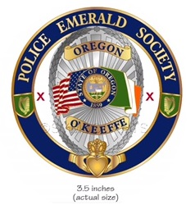

Patch: Oregon Police Emerald Society Patch.
Order from Terry O’Keeffe. Cost is $5.50 plus S&H.
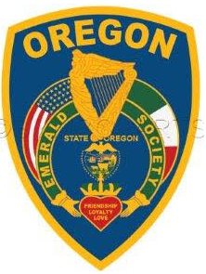

Uniform Shirt: LawPro 100% Polyester Uniform Shirt – Black.
Long Sleeve - Black
$10.99 – 27.99
LawPro Long Sleeve Uniform Shirt
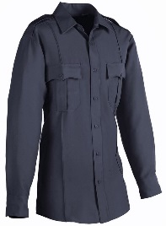
Click picture to buy/visit site

Kilt: Members may choose from two versions of the “Black Watch Ancient” Tartan.
Option #1
5 Yard Premium Poly/Viscose Kilt
$325-405
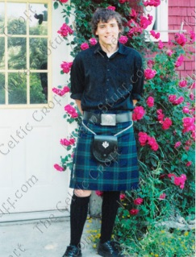
Click picture to buy/visit site

Sporran: “Oregon Police Emerald Society” – Black leather fur body with silver tassels and blue, leather tips (Keeping with the “thin blue line” theme). Will include silver badge on flap.
*You can Specify Deputy Sheriff to be on badge

$195
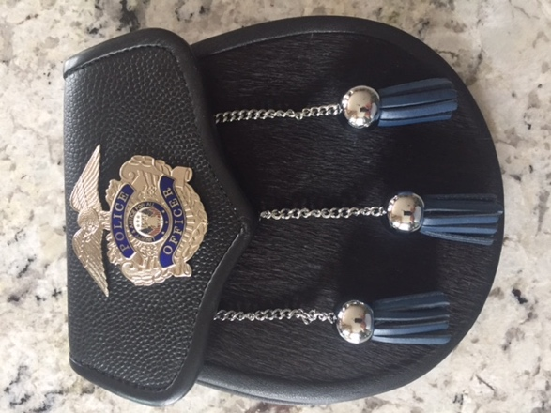

Click picture to buy/visit site

Belt: Members may choose from two versions.
Option #1 Option #2
$55-60 $30
Quality Embossed Leather Kilt Belt Standard Pebble Grain Leather Kilt Belt
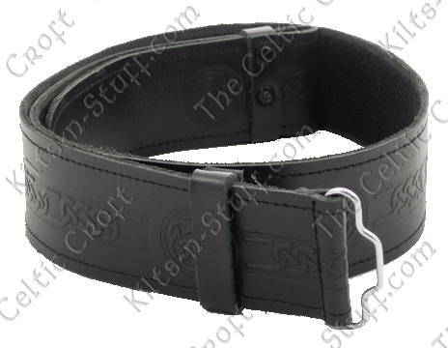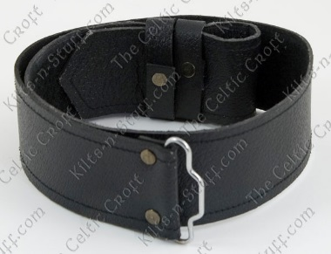
Click picture to buy/visit site Click picture to buy/visit site

Buckle:
-Members may add their military service insignia or clan crest
-Color must be chrome, pewter or silver (not gold, brass or otherwise conflict with
badge)
*We ask that you choose a rectangular buckle but feel free to pick the design of your choice. Below are just a few examples of options available.

Example #1 Example #2

Quality kilt buckles Standard kilt buckles
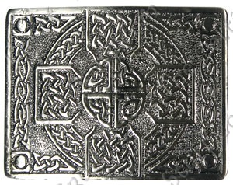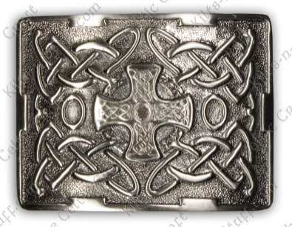
Click picture to buy/visit site Click picture to buy/visit site

Example #3

Clan crest kilt buckles
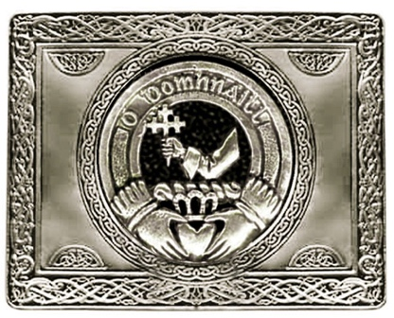

Click picture to buy/visit site

Glengarry (Hat): “Black Watch Ancient” Tartan – Tartan Glengarries
$49

Tartan Glengarries “Black Watch Ancient”
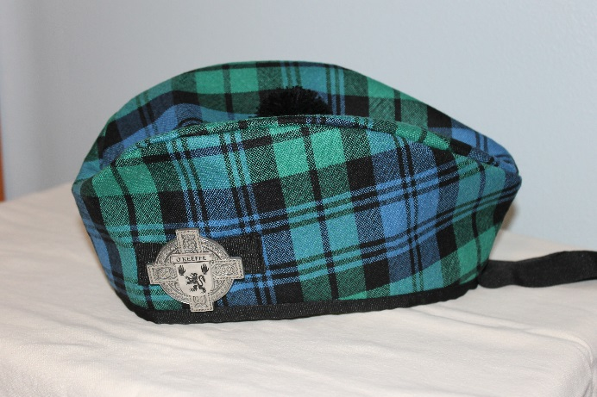

Click picture to buy/visit site

Cap Badge (Brooch):
- Members may add their military service insignia or clan crest

*Below are a few examples of cap badge options you can choose from

$25-180

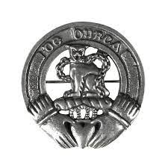

Click picture to buy/visit site

Kilt Hose (Socks): Economy Wool Blend Kilt Hose (Black)

$40
Economy Wool Blend Kilt Hose “Black”
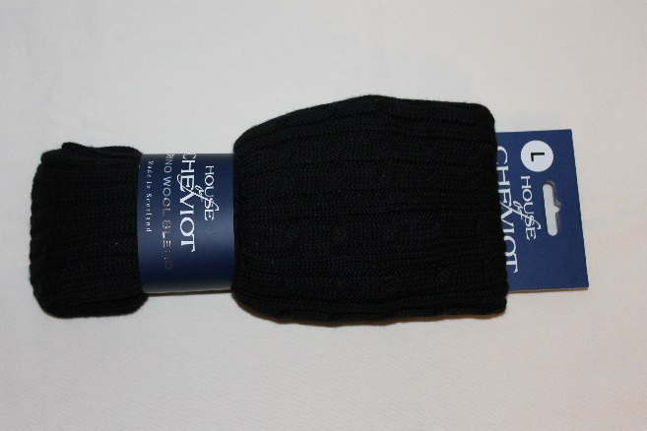

Click picture to buy/visit site

Flashes (Worn over Kilt Hose): Wool flashes
$30

Wool Flashes “Ancient Blue”
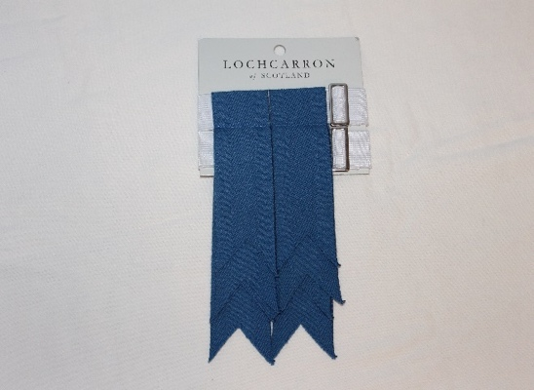

Click picture to buy/visit site

Ghillie Brogues (Shoes): All black shoes with a high polish and “broguing”
-No boots, no buckles
Example #1 Example #2
$99 $159
Synthetic Sole Ghillie Brogues Light Weight Piper Ghillies
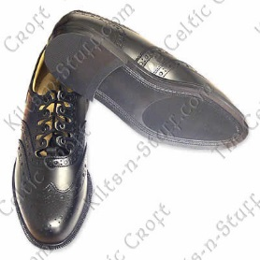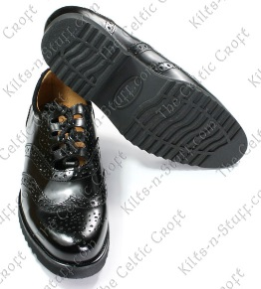
Click picture to buy/visit site Click picture to buy/visit site

Kilt Pins:
-Members may add their military service insignia or clan crest
-Color/material must sterling silver or pewter (not gold or brass)
*The link below will take you to the page with several choices of kilt pins

Prices vary depending on style and material
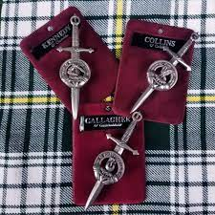
Click picture to buy/visit site

